**Q-smart 850 – Addition of an Harmonic Generator**

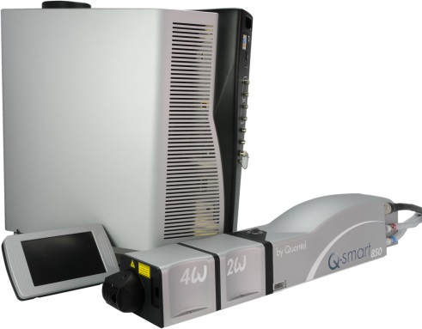

**Toolkit :**

Allen keys

Screwdrivers

Powermeter

**System**: QSMART 850

**Purpose**: This document details how to install an Harmonic Generator on an existing Q-smart 850.

**Safety :** During all the procedure, you must wear eye protection goggles required according to EN207-208.

**Conditions**: Each Harmonic module has to be installed and checked one after the other one.

**SHG or THG installation procedure**

**FHG installation procedure**

## **Description of the different steps**

### Installing the SHG module

### It is assumed that the oscillator delivers standard specifications: 850mJ at 1064nm

### Use the following steps to attach the 2ωHG module to the Laser Head:

### Verify that the AC Mains power is turned OFF.

### Remove 2 screws fastening the 2ωHG outer cover and set it aside.

### Position 4 screws in the HGM mounting plate.

### Raise the HGM and align its pin, connector, and circular guide to the matching features on the Laser Head.

### Tighten the 4 pre-positioned screws to fasten the HGM to the Laser Head.

### 

### Figure 1: Installing the 2ω Module

### Installing the THG or FHG module

### Use the following steps:

### 1. Verify that the AC Mains power is turned OFF.

### 2. Remove 2 screws from the dichroic module to detach the dichroics with the beam block from the HG module in use. Place this dichroics module in the storage container.

### 3. Remove the cover from the HG module to be added.

### 4. Align the additional HG module to the pin, connector, and circular feature on the existing HG module.

### 5. Tighten four screws to fasten the added module.

### 6. Attach the appropriate dichroics module. For example, when the 3ωHG module is the last module installed, use the 3ω dichroics; when the 4ωHG module is the last module installed, use the 4ω dichroics.



### Figure 2: Installing the 3ω/4w Module

### Launching the APM (Automatic Phase Matching)

### Run the system using the Q-touch.

### On the “harmonics tab”, wait for System status: LASER ON – NLO ready.

### Then, select the harmonic generator that has just been installed :

### If 2w has been installed press on the “2w” button (see figure 3).

### If 3w or 4w, press on the “3w” button or” 4w “(see figure 4)

### Then, press on Start button to launch the APM.

### Once APM is complete, a message appears where you can accept or cancel the new operation set point. If you select YES, APM is complete. If you select No, the system returns to the previous setting and may take few minutes to restabilize.

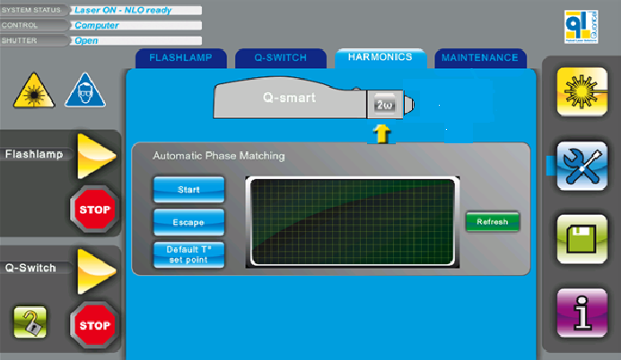

### Figure 3: Launching the APM for the 2w

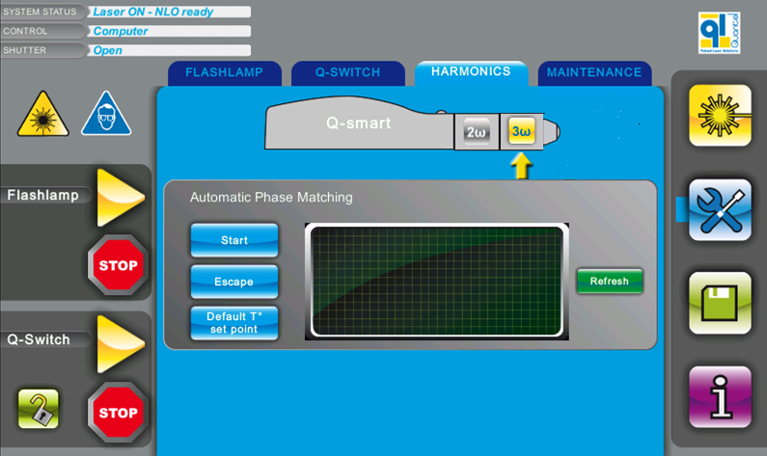

### Figure 4: Launching the APM for the 2w

### Angle tune the SHG

### Unscrew the “lock”screw (side) to allow crystal rotation (see Figure 5).

### 

### Figure 5: Lock screw for SHG crystal

### Rotate the “adjusting” screw (top) clockwise or anticlockwise to optimize the energy. The system goes back to its position each turn ( no position stop). See Figure 6.

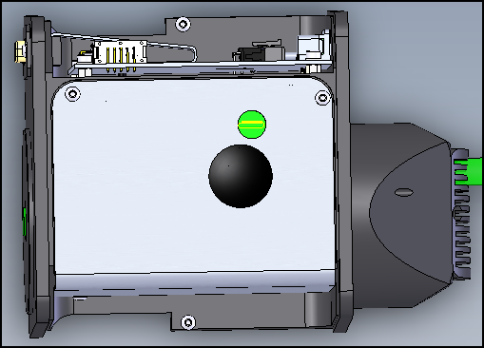

### Figure 6: Ajuqting screw for SHG crystal

### Screw the “lock” screw (side) and replace the cover (see Figure 5)

### Angle tune the THG or the FHG

### It is assumed that the second harmonic generator has been phase matched and delivers full specifications.

1. Unscrew the “lock”screw (top) to allow crystal rotation (warning: the location of the rotation screw is different from 2w harmonic generator), see Figure 6.

### 

### Figure 6: Lock screw for THG or FHG crystal

### 2. Rotate the “adjusting” screw (top) clockwise or anticlockwise to optimize the energy (see Figure 7).

### Use a “white card” to visually find the optimum point. Then Adjust finely by checking the energy level on the powermeter.

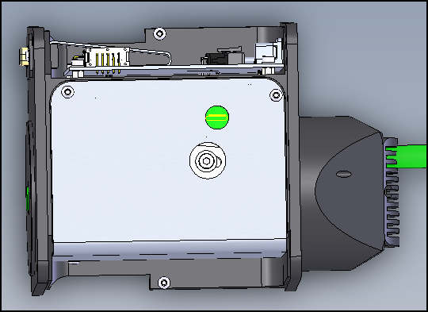

### Figure 7: Adjusting screw for THG or FHG crystal

### Screw the “lock”screw (top, see Figure 6) and replace the cover.